What Would Thomas Do?
In 1802, western farmers were devastated when Spain once again blocked their main port in New Orleans and gave it to the French. The president, Thomas Jefferson, had long believed that farmers were the best the new America had to offer the world. This move by Spain, which had nearly led to war 10 years prior, left Jefferson in a tough position. His powers as president were heavily limited by the Constitution, which he held to be unarguable. What would Thomas do?

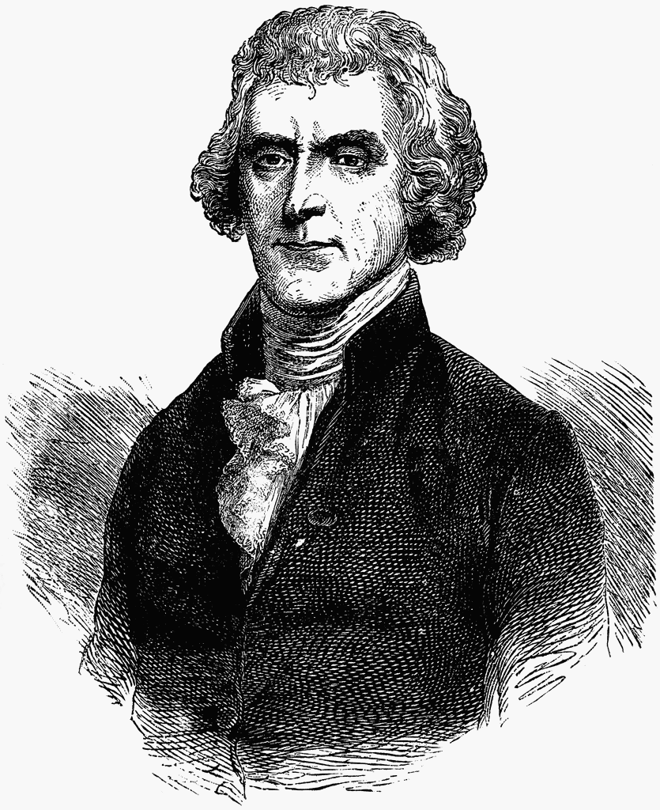
Instructions: Read the documents on the following pages one by one and answer these questions in complete sentences on your own paper. Answer each set of questions before moving on to the next document.

Document A: The Louisiana Territory Problem

What did Jefferson pledge to do when elected president?
- In a few sentences summarize the problems posed by the Louisiana Territory.
Document B: Selections from the Constitution
- Based on your reading of these sections of the Constitution does any part of the government have the legal authority to purchase new lands? Explain.

- Article 1, Section 18, Part 18 contains what is commonly called the “necessary and proper” clause. Explain what you think this small part means.

- If you were Thomas Jefferson faced with this problem and the limits of the Constitution what would you do to solved the Louisiana Territory problem? Explain in a complete paragraph.
Document C: Jefferson’s Response
- Summarize Jefferson’s response to the crisis in a few sentences.

- Jefferson once said that in government “What is practicable must often control what is pure theory” meaning that what we can accomplish often is not exactly what we believe to be best. In the case of the Louisiana Territory he had to go against his own stated beliefs to make this purchase. In your opinion did he make the right decision?

- How would you feel if a modern president went outside the Constitution to do something that he felt was best for the country? Would you be okay with it? Why or why not?

Document A:
TedED Clip
http://ed.ted.com/lessons/the-audacity-behind-the-louisiana-purchase-judy-walton
Stop video at 2:01 mark after it asks “So, what was a strict constructionist to do?”

Document A: The Louisiana Territory Problem

What did Jefferson pledge to do when elected president?
- In a few sentences summarize the problems posed by the Louisiana Territory.

-or- https://www.billofrightsinstitute.org/educate/educator-resources/lessons-plans/presidents-constitution/louisiana-purchase/

France had given up all of its territory in North America by the end of the French and Indian War (1763). But Napoleon had plans to re-establish the French empire in North America. In 1801, America learned that Spain had agreed to return Louisiana to France. Jefferson had always looked upon France as a friend in the world, but he knew this was a potential crisis. The new nation depended on New Orleans for its economic survival.
In early 1803, Jefferson appointed James Monroe as a special envoy to France. Monroe and Minister to France Robert Livingston would try to buy land east of the Mississippi or in New Orleans itself, or, if all else failed, to secure U.S. access to the river. Jefferson authorized them to negotiate up to $10 million. Monroe and Livingston learned that Napoleon had given up his desire to recreate an empire in North America. France offered the U.S. the entire Louisiana territory—more than 800,000 acres from Louisiana to the Rockies and beyond—for $15 million. The two American ministers seized the opportunity, going beyond their mandate. They negotiated a purchase treaty and returned to the U.S. in time for an announcement to be made on July 4, 1803.
The Louisiana Purchase Treaty would not be final until it was ratified by the Senate, funded by the House of Representatives, and signed by the President. While the incorporation of these new lands into the United States was a momentous opportunity, Jefferson had reservations about its constitutionality. Jefferson had always stated his strong belief that the federal government’s powers should be interpreted strictly.

Document B: Selections from the Constitution (Simplified)

Article 2, Section 1- The President’s Role
7. Before he enter on the execution of his office, he shall take the following oath or affirmation: "I do solemnly swear (or affirm) that I will faithfully execute the office of the President of the United States, and will to the best of my ability, preserve, protect and defend the Constitution of the United States."
Article 1, Section 8 – Congressional Powers
2. The Congress shall have Power to regulate commerce (trade) with foreign nations and among the states and with the Indian Tribes.
18. To make all Laws which shall be necessary and proper to make it possible to perform their duties, and all other Powers given by this Constitution in the Government of the United States, or in any Department or Officer in it.

Article 2, Section 2 – Presidential Powers

2. He shall have Power, by and with the Advice and Consent of the Senate, to make Treaties [with foreign nations], provided two thirds of the Senators present agree;

Article IV, Section 3 – New States
1. New States may be admitted by the Congress into this Union; but no new State shall be formed within the borders of any other State; nor any State be formed by combining two or more States, or Parts of States, without the Consent of the Legislatures of the States concerned as well as of the Congress.
2. The Congress shall have Power to dispose of and make all needful Rules and Regulations respecting the Territory or other Property belonging to the United States;
Document B: Selections from the Constitution
- Based on your reading of these sections of the Constitution does any part of the government have the legal authority to purchase new lands? Explain.

- Article 1, Section 18, Part 18 contains what is commonly called the “necessary and proper” clause. Explain what you think this small part means.

- If you were Thomas Jefferson faced with this problem and the limits of the Constitution what would you do to solve the Louisiana Territory problem? Explain in a complete paragraph.

Alternate B: Jefferson to Breckinridge Letter
http://teachingamericanhistory.org/library/document/letter-to-john-c-breckinridge/
“This treaty must of course laid before both Houses, because both have important functions to exercise respecting it. They, I presume, will see their duty to their country in ratifying & paying for it, so as to secure a good which would otherwise probably be never again in their power. But I suppose they must then appeal to the nation for an additional article to the Constitution, approving & confirming an act which the nation had not previously authorized. The constitution has made no provision for our holding foreign territory, still less for incorporating foreign nations into our Union. The Executive in seizing the fugitive occurrence which so much advances the good of their country, have done an act beyond the Constitution. The Legislature in casting behind them metaphysical subtleties, and risking themselves like faithful servants, must ratify & pay for it, and throw themselves on their country for doing for them unauthorized what we know they would have done fro themselves had they been in a situation to do it. It is the case of a guardian, investing the money of his ward in purchasing an important adjacent territory; & saying to him when of age, I did this for your good; I pretend to no right to bind you: you may disavow me, and I must get out of the scrape as I can: I thought it my duty to risk myself for you. But we shall not be disavowed by the nation, and their act of indemnity will confirm & not weaken the Constitution, by more strongly marking out its lines.
We have nothing later from Europe than the public papers give. I hope yourself and all the Western members will make a sacred point of being at the first day of the meeting of Congress; for vestra res agitur.
Accept my affectionate salutations & assurances of esteem & respect.”

Document C: Online Textbook Passage on Louisiana Purchase
Blocking American access to New Orleans was such a grave threat to American interests that President Jefferson considered changing his traditional foreign policy stance to an anti-French alliance with the British. At the same time that he sent diplomats to France to bargain for continued trade access along the Mississippi, he also sent diplomats to Britain to pursue other policy options. James Monroe, the top person negotiating in Paris, was empowered to purchase New Orleans and West Florida for between two and ten million dollars.
The deal was struck in April 1803, but it brought a good deal of controversy. While American development in the 19th century depended on western expansion, it also raised controversial issues that might lead to the disunion of the United States.
Jefferson had clearly not followed his own strict interpretation of the Constitution. Federalist critics howled that the Constitution nowhere permitted the federal government to purchase new land. Jefferson was troubled by the inconsistency, but in the end decided that the Constitution's treaty-making provisions allowed him room to act.
Most of the Senate agreed and the Louisiana Purchase easily passed 26 to 6. The dramatic expansion also contradicted Jefferson's commitment to reduce the national debt as swiftly as possible. Although 15 million dollars was a relatively small sum for such a large amount of land, it was still an enormous price tag for the modest federal budget of the day.
The Louisiana Purchase demonstrates Jefferson's ability to make sensible and realistic political decisions. Although contrary to some of his central principles, guaranteeing western expansion was so important to Jefferson's overall vision that he took bold action. The gains were dramatic, as the territory acquired would in time add 13 new states to the union. In 1812, Louisiana became the first state to join the union from land bought in the purchase.
http://www.ushistory.org/us/20c.asp

Document C: Jefferson’s Response
- Summarize Jefferson’s response to the crisis in a few sentences.

- Jefferson once said that in government “What is practicable must often control what is pure theory” meaning that what we can accomplish often is not exactly what we believe to be best. In the case of the Louisiana Territory he had to go against his own stated beliefs to make this purchase. In your opinion did he make the right decision?

- How would you feel if a modern president went outside the Constitution to do something that he felt was best for the country? Would you be okay with it? Why or why not?

Close with discussion of presidential powers and possibly this article.

http://www.nytimes.com/interactive/2016/11/21/us/politics/what-trump-wants-to-do-in-his-first-100-days-and-how-difficult-each-will-be.html?partner=IFTTT&_r=0

