St. Michael School

Sixth-Seventh-Eighth Grade Supply List
2017-2018
Subject Area Supplies:
Science | Math | English Language Arts | Social Studies | Religion
- 2 inch binder to share with Sci. & Eng. | - 2 inch binder to share with Math & Soc. |  |  | - 1 inch binder
(1) red spiral notebook | (1) blue spiral notebook | (1) yellow spiral notebook | (1) green spiral  notebook | (1) purple spiral notebook
(1) red plastic folder for  binder  (1) pack of  loose leaf college ruled paper for binder | (1) blue plastic folder for binder  (1) pack of loose leaf college ruled paper for binder | (1) yellow plastic folder for binder  (1) pack of loose leaf college ruled paper for binder | (1) green plastic folder for binder  (1) pack of loose leaf college ruled paper for binder | (1) purple plastic folder for binder  (1) pack of loose leaf college ruled paper for binder
(10) dividers with tabs for shared binder: Sci. & Eng. | (1) graph paper | (1) multi-folder for writing portfolio | (10) dividers with tabs for shared binder: Math & Soc. | (1) Catholic Youth Bible
Classroom Supplies:

- Google email account for school use 11. Planner (available at school $5)
- Book Bag 12. Gym Shoes
- # 2 Pencils 13. Pencil Cap Erasers
- Ink Pens: black and red 14. Ink Pens: colors for note-taking
- White Out Tape 15. Crayola Markers
- Crayons 16. Colored Pencils
- Scissors 17. Ruler
- Lined paper – college ruled 18. Printer paper / typing
- Glue sticks and liquid 19. Index cards
- Sticky notes – any kind 20. USB for Computer (thumb drive)
21. Art sketchbook
Choose at least 4 from the following items:
Kleenex or Tissues Paper Plates Cups Paper Towels
Plastic Forks, Spoons, Knives Ziplock Bags Manila file folders
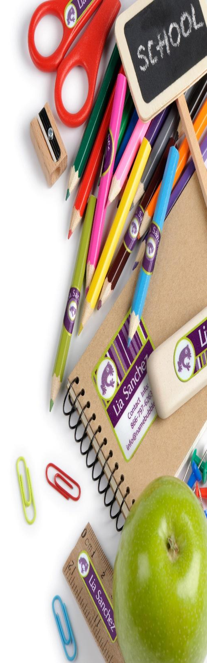
Hand Sanitizer Napkins Bandaids Disinfecting wipes

Thank You,
Mrs. Grzegorczyk & Mrs. Sprywa

