Document 1:
Achieving Moksha is the Goal of Life To Hindus every person has an essential self or atman
Some view it as the same as Brahman and other as a form of Brahman. The ultimate goal of existence, Hindus believe, is achieving moksha, or union with Brahman. To do that, individuals must free themselves from selfish desires that separate them from Brahman. Most people cannot achieve moksha in one lifetime, but Hindus believe in reincarnation, or the rebirth of the soul in another bodily form. Reincarnation allows people to continue world toward moksha through several lifetimes.
--Adapted from Prentice Hall World history, Ellis and Esler
Document 1 Question: According to this excerpt, what is the purpose of reincarnation?

Document 2:
The following depicts the origins of the Hindu Caste system.
The four major castes emerged from Purusha (the first human being). Purusha is identified with the creator god Brahma.
- The Brahmins: The priestly class, born from the mouth of Brahma.
- The Kshatriyas: Warriors and rulers, senators, presidents, majors, born from the chest of Brahma
- The Vaisyas: Farmers, merchants, lawyers, doctors.
- The Sudras: Unskilled workers. Born from the feet of Brahma.
- Other sub-castes: Up to 3,000 sub-castes, with the untouchables at the bottom.
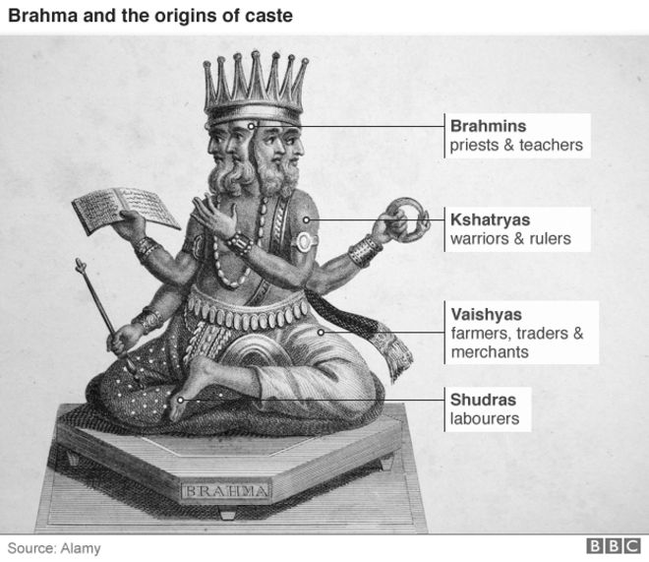
Document 2 Question: According to this diagram, who were the largest group in Indian society?

Document 3:
The four truths are presented within the Buddha's first discourse, Setting in Motion the Wheel of the Dharma An English translation is as follows:
1. "This is the noble truth of [suffering]: birth is [suffering], aging is [suffering], illness is [suffering], death is [suffering]; sorrow, lamentation, pain, grief and despair are [suffering]; union with what is displeasing is [suffering]; separation from what is pleasing is [suffering]; not to get what one wants is [suffering]; in brief, the five aggregates subject to clinging are [suffering]."
2. "This is the noble truth of the origin of [suffering]: it is this craving which leads to renewed existence, accompanied by delight and lust, seeking delight here and there, that is, craving for [physical] pleasures, craving for existence, craving for extermination."
3. "This is the noble truth of the cessation of [suffering]: it is the remainderless fading away and cessation of that same craving, the giving up and relinquishing of it, freedom from it, nonreliance on it."
4. "This is the noble truth of the way leading to the cessation of [suffering]: it is the Noble Eightfold Path; that is, right view, right intention, right speech, right action, right livelihood, right effort, right mindfulness and right concentration."
--Adapted from Dhammacakkappavattana Sutta, translated by Thanissaro Bhikkhu
Document 3 Question: According to the Siddhartha Gautama (the Buddha), what is the origin of people's suffering?

Document 4:
The Eightfold Path
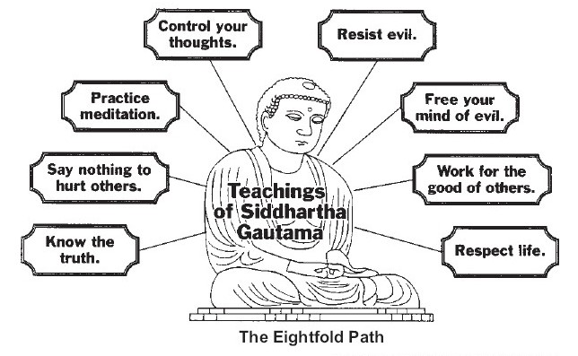
Source: The Human Experience; Glencoe
Document 4 Question: According to Siddhartha Gautama [the Buddha] what is an important part of the eightfold path.

PART B: ESSAY
Directions: Write a short essay that evidence from all four documents in your essay. Support your response with relevant facts, examples, and details. Include additional outside information.
Historical Context:
Throughout history, belief systems have influenced social, economic, and political developments in many regions. Although different, these belief systems often have similarities and, in some cases grow out of one another. Two such examples are Hinduism and Buddhism.
Task(s): Using the information from the documents and your knowledge of global history, write an essay in which you:
• Describe the key beliefs and practices of both Hinduism and Buddhism.
• Discuss the differences, similarities and relationship between the two belief systems.
Guidelines: In your short essay, be sure to
• Develop all aspects of the task
• Incorporate information from all four documents
• Support the theme with relevant facts, examples, and details

PART B: ESSAY
Directions: Write a short essay that evidence from all four documents in your essay. Support your response with relevant facts, examples, and details. Include additional outside information.
Historical Context:
Throughout history, belief systems have influenced social, economic, and political developments in many regions. Although different, these belief systems often have similarities and, in some cases grow out of one another. Two such examples are Hinduism and Buddhism.
Task(s): Using the information from the documents and your knowledge of global history, write an essay in which you:
• Describe the key beliefs and practices of both Hinduism and Buddhism.
• Discuss the differences, similarities and relationship between the two belief systems.
Guidelines: In your short essay, be sure to
• Develop all aspects of the task
• Incorporate information from all four documents
• Support the theme with relevant facts, examples, and details

Day One:
Title: What is a Primary Source Document and how do we analyze them?
Instructional Objective : The students will learn how to recognize different types of primary source documents and how to analyze them by taking a guided tour of some interesting documents and creating a "How to" list to use for the rest of the year.
Standards:
E1c-Read and comprehend informational materials.
E1d-Demonstrate familiarity with a variety of public documents.
E1e-Demonstrate familiarity with a variety of functional documents.
E3b Participate in group meetings.
E5a-Respond to non-fiction using interpretive and critical processes.
Do Now : Copy the definition of a primary Source document.
Primary Source- A primary source is firsthand testimony or direct evidence concerning a topic under investigation. A primary source gives the words of the witnesses or the first recorders of an event. Primary sources include letters, diaries, speeches, maps, pictures, art work, posters, manuscripts, artifacts, and music.
Which one of these is not a primary Source and why? List on Board: 1.A book written by my friend last year about the Civil War. 2. A photograph of soldiers taken in 1945 during World War II 3. A picture of an artifact found in Ancient Egypt. 4. A copy of the Constitution. 5. A map of the English Colonies drawn by a student. 6. A diary page of a girl during the depression.
Mini Lesson: What is a primary source?
Review the Do Now and explain why each example is what it is and make sure the students understand that a copy of a document such as the Constitution is still a primary source even though it is a copy.
Have the students recall the list of the types of primary sources and write the list on chart paper to display in the classroom.
Now go into a discussion on why primary sources would be beneficial for us in the classroom. Lead the discussion into asking them to think about how as students they should go about analyzing a document.
Work Period : How do we analyze a document?
In groups of four or five ask the students to discuss what steps they think they should follow when looking at a document and trying to learn something from it. Have them work together to create a list.

Share Out/Conclusion: Have one person from each group read their list to the class. Write their steps on the board putting a check next to any repeats. From the class list choose or condense them into a complete "How to Analyze a Primary Source Document" list. Transfer the finished product on to Chart paper and display it in the room. Have the students copy it into their notebooks.
Homework: Think about the content that we will cover this year in Social Studies. Make a list of some primary sources that you think we should look at during the year to help us to learn the curriculum in a more in depth way.

Day Two:
Title: Let's Put Our Newly Learned Skills to Work!
Instructional Objective: We will practice our analyzing skills by looking at a series of documents during a webquest and applying our "how to" list. We will write our responses in our notebooks.
Standards:
E1c-Read and comprehend informational materials.
E1d-Demonstrate familiarity with a variety of public documents.
E1e-Demonstrate familiarity with a variety of functional documents.
E3b-Participate in group meetings. (Choice 2 only)
E5a-Respond to non-fiction using interpretive and critical processes.
Do Now: Take out homework and discuss your thoughts within your group. Pick three that your group is most interested in. (Give each group time to share out)
Explain to the students that they should have their "how to" lists open during the entire class.
Mini Lesson: Choose one interesting document, it can be from any time period. Your goal is to make it interesting enough to motivate them to want to see more documents and explore them.
Guided Practice: Put the document on the overhead or use a projector to allow them to view one from the Internet and guide the students through the how to list. Point out any things that they should pay close attention to or learn from. Prompt their discussion with questions like why is that like that or why did they do that. Stress the significance of the document and the things learned from it.
Work Period: This is where the students will perform their web quests. Assemble them into groups of three or four. Each group will need a computer with Internet access. Give them the attached list of various sites where they can access primary source documents. They should choose when and use their "How To" list to analyze it. They should be writing their responses in their notebooks.
Share out/Conclusion:
Have each group report their findings to the rest of the class.
Homework: Ask the students to find one of their own documents and use the how to list to analyze it in their notebooks. Tell them to use their textbooks or the Internet.
Day Three:
Title: What is a DBQ and how do I start it?
Instructional Objective: The students will become familiar with the term DBQ and begin the writing process by learning the parts of an introduction and practicing how to write topic sentences.

Standards:
E2b Produce a response to literature
E4a Demonstrate an understanding of the rules of the English Language in written and oral work.
E4b Analyze and subsequently revise work to improve its clarity and effectiveness.

Do Now: Copy the following:

An Introduction is the first paragraph of an essay. It is similar to a first impression. The first sentence is called the catch or the hook sentence because you have to catch your readers' attention. Think about how you choose a book, by reading the title or the first line. You want to leave a sense of mystery so the reader will want to read on. So ask a question (Can you imagine what it would be like to travel on a boat for three months straight wearing the same clothes) or give a startling fact (3,360 people dead another 5,000 wounded. Was it worth it?) Then you have to state your thesis or your purpose for writing. You can use the historical setting or you can take a little information from each task you have to answer.

Introduction checklist:

-Catch sentence (make it exciting and mysterious)

-State your topic

Mini Lesson: Start out by explaining what a document based question is and talk about the eighth grade state exam. Give them a brief synopsis of the parts of a DBQ and what they are required to do in answering it. Explain the five paragraph essay model and tell them that we will work on each part separately first and then put it all together. Distribute the DBQ rubric (this can be obtained from the following website: http://upstatehistory.org/services/DHP/DBQ.html) and tell them today we will begin with the introduction. Discuss the notes copied in the do now and thoroughly explain each part. Stress the importance of the catch sentence.

Work Period: Write topics on chart paper. Begin with very exciting and very familiar things. For example: The talent show, Christmas, The school trip. Then gradually make them a little less exciting and more content geared. The nomads, exploring the US. Finally give them the topic of the DBQ that you will begin working on. (I am up to the thirteen colonies so I will be using that DBQ you should use whatever is pertinent to your curriculum. Use something that you taught in the recent past it is easier when they have background knowledge.) Ask the students to pretend they were writing essays on these topics and write a catch sentence for each one. After they finish allow them time to share with their group.

Medial Summary: Stop them and allow them to share out. Call on a few kids to share their sentences for each topic. Point out strong answers and make suggestions to improve the others. Remind the students that the next step is state your topic and ask them to choose two of the catch sentences they just wrote, one easy one and one to do with social studies, and finish the introduction for them.

Conclusion: Finish up by calling on random students to share their finished products. Again make comments and suggestions.

Homework: Distribute the DBQ of choice. Ask the children to look at the documents and answer the question under each document. Then tell them to read the historical setting and the tasks and write an introduction. Direct them to this website for sample student work and rubric support:

http://upstatehistory.org/services/DHP/DBQ.html

Day Four:

Title: Now that we've introduced ourselves to DBQs lets get to the BODY!

Instructional Objective: We will develop the body of our DBQ essay by learning the parts, then drafting and editing.

Standards:
E2b Produce a response to literature
E4a Demonstrate an understanding of the rules of the English Language in written and oral work.
E4b Analyze and subsequently revise work to improve its clarity and effectiveness.

Do Now: Take out your DBQ packet and introductions and switch with someone in your group. Peer edit each others introduction use yesterdays notes as a guide.

Give them ten minutes. Walk around and glance at everyone's paper making sure everyone is on the same page. If all is satisfactory end the do now by asking a few students to talk about some editing suggestions they made.

Mini Lesson: First go over the short answers underneath each document from last night's homework. Then, teach the students the steps they need to follow in order to properly construct the body. Refer them to the rubric you gave them yesterday. Have them copy the following under the title of "What is a DBQ." Go over the definition and the following points.

¨ Address each task completely. You need one paragraph for each task.

¨ Use and cite the documents to answer the tasks. USE ALL DOCUMENTS.

(Depending on the students you can have them cite in two ways. They can directly say "in document 1 or 2 it tells us ...... or they can just say as shown in the documents....or they can just make sure they use all the information in the documents. You can start them out directly citing and then phase it out as they get better at it.)

¨ Use appropriate vocabulary for the content.

¨ Add in outside information for each task; something that was not given in the documents.

¨ Make sure you have a topic sentence at the beginning of each paragraph.

Explain each one.

Work Period: Handout the vocabulary list of words commonly used in the tasks. Go over the meaning of each word. Move on to: Guided/modeled writing. Take the first task and go through each step with it. Create the first paragraph of the body with the class as an example or show them a sample piece of student work. Have them work together to create suggestions sentence by sentence. Have them share out and create the paragraph from their suggestions. Go back and check that it has all the components and edit and revise it together. Concentrate on the citations of the documents.

Conclusion: End the lesson by reviewing the parts of the body again, as well as the ways of citing the documents and where they should look for the outside information. Then open the floor for questions about the modeled writing piece we created

Homework: Now it's your turn! Take your packet and your notebook home and try to answer task two on your own. Follow the checklist and use the answer we developed to task one as your guide.

Day Five:

Title: Now that we've introduced ourselves to DBQs lets get to the BODY! Continued!

Instructional Objective: We will continue develop the body of our DBQ essay by reviewing the parts, then drafting and editing.

Standards:
E2b Produce a response to literature
E4a Demonstrate an understanding of the rules of the English Language in written and oral work.
E4b Analyze and subsequently revise work to improve its clarity and effectiveness.

Do Now: Take out your homework from yesterday. Begin to write a topic sentence for task three.

Work Period (Half): Peer editing. Switch notebooks and peer edit task two. Use the rubric and checklist to edit. Switch back and make adjustments to task two.

Mini Lesson: After the editing and revising stop the students and review the checklist, listen to some sharing out, making sure the students are citing correctly.

Work Period (2 nd Half): The students should now independently write the last paragraph for the third task. If time permits allow them to peer edit again.

Conclusion: Have some students read their entire essay so far so the kids' ears will hear the flow of the essay. Comment and make suggestions for any choppy work.

Homework: Ask the students to read their essay so far and write down what they think the most important sentence or point in the essay is. It can be more than one sentence.

Day Six:

Title: Let's wrap it up and I don't mean a present!

Instructional Objective: We will end our DBQ essay by learning the parts of a conclusion then by drafting and editing.

Standards:
E2b Produce a response to literature
E4a Demonstrate an understanding of the rules of the English Language in written and oral work.
E4b Analyze and subsequently revise work to improve its clarity and effectiveness.

Do Now: Journal Entry: Why do we need to have a concluding paragraph in an essay?

Discuss the students' answers. Lead into the mini lesson and develop the parts of a conclusion.

Mini Lesson: What should go into a conclusion. Ask the students why they think songwriters write a chorus and repeat it so many times. Make a connection between the chorus of a song and a conclusion. Explain that the most important points are restated more than once so people understand and remember. The conclusion should have the following:

© Restate your topic. (look at the introduction and re-word your thesis)

© Restate your most important point.

© You can add your opinion here and only here.

Work Period: Have the students draft a conclusion to their essay. Then have them switch and peer edit. When they switch back have them read their entire essay and edit and revise once again. (At this point you should also be walking around and conferencing with the students, helping them edit and revise.)

Conclusion: Hand out the TODVID worksheet. (see appendix) Review the checklist. Ask for questions.

Homework: The students should take their drafts and checklists home with them and complete a final draft. It should be typed and double-spaced. If they do not have the capability to do this at home then you will need to provide them with class time to do it

